Function Realisation(CADS4) 2

LKA SUBSYSTEM 2

Function Realisation – FR specifications 2

1 INTRODUCTION 3

2 TERMINOLOGY 3

2.1 Abbreviations 4

3 INPUT FUNCTION REQUIREMENTS 4

3.1 Safety LKA 4

3.1.1 Safety LKA: One Pager 4

3.1.2 Safety LKA: Use cases 4

3.2 LDW 5

3.2.1 LDW:One pager 5

3.2.2 LDW:Use cases 5

3.3 Emergency LKA 6

3.3.1 Emergency LKA: One pager 6

3.3.2 Emergency LKA: Use cases 7

4 FUNCTION REALIZATION DESCRIPTIONS 7

4.1 Overview of function realization 8

4.2 Summary of involved subsystem responsibility 8

4.3 Central interfaces 8

4.3.1 Sensor data interface CADS4 8

4.3.2 Vehicle Dynamics Management interface 9

4.3.3 HMI Management and Display interface 11

5 FR REQUIREMETS ON SUBSYSTEMS 12

5.1 LKA Requirements on Active Safety Management 12

5.2 LKA Requirements on Environment and Driver Perception 13

5.3 LKA requirements on Vehicle Dynamics Management 14

5.4 LKA Requirements on Steering 14

5.5 LKA Requirements on Inertia Monitor 14

5.6 LKA Requirements on User Inputs 15

5.7 LKA Requirements on Driver Priority 15

# Function Realisation(CADS4)

## LKA SUBSYSTEM

Inside excel contains the FR requirements on subsystems in the logical electrical architecture.

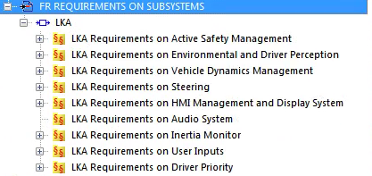



## Function Realisation – FR specifications

The Volvo function module includes the following:

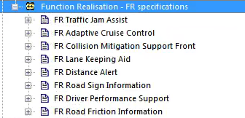

The structure of FR Lane Keeping Aid document is explained below:

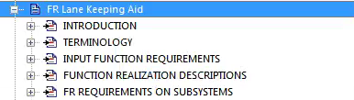

### 1 INTRODUCTION

The structure of this document is explained below:

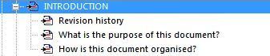

Relation between information and documentation for a customer function,a function realization,involved subsystems and ECUs

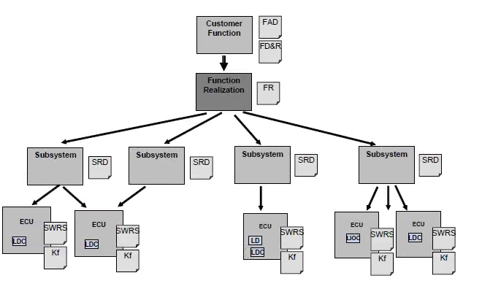

### 2 TERMINOLOGY

The structure of TERMINOLOGY is explained below:



#### 2.1 Abbreviations

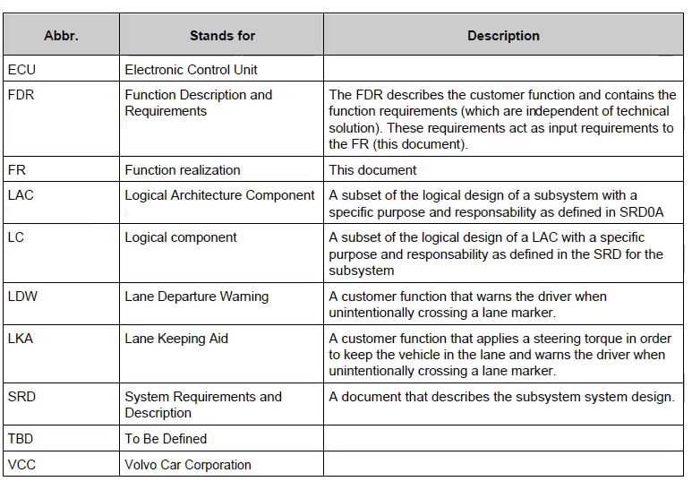

### 3 INPUT FUNCTION REQUIREMENTS

The structure of this documnent is explained below:

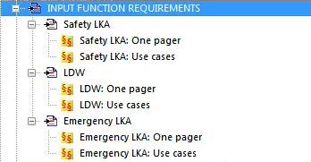

#### 3.1 Safety LKA

##### 3.1.1 Safety LKA: One Pager

Safety Lane Keeping Aid(S-LKA)

##### 3.1.2 Safety LKA: Use cases

sLKA Scenario:Risk for lane departure

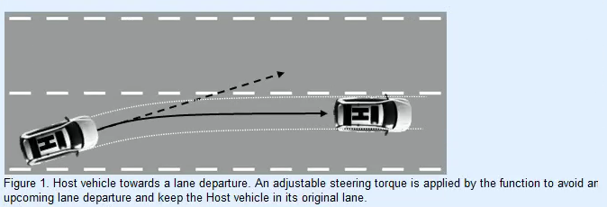

sLKA Scenario:Cutting curve

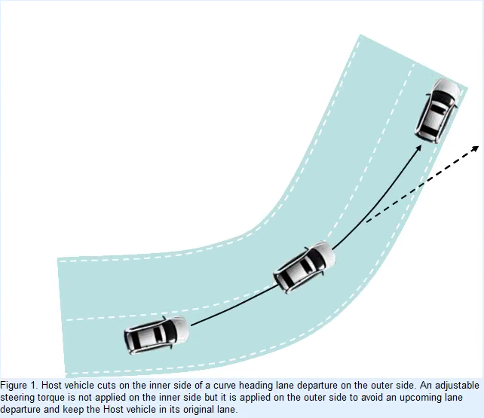

#### 3.2 LDW

##### 3.2.1 LDW:One pager

Customer Function

Function Description

Function Handling

##### 3.2.2 LDW:Use cases

LDW Scenario:Haptic or audible warning at lane departure

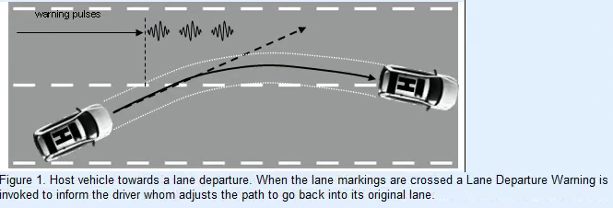

LDW Scenario: Cutting curve

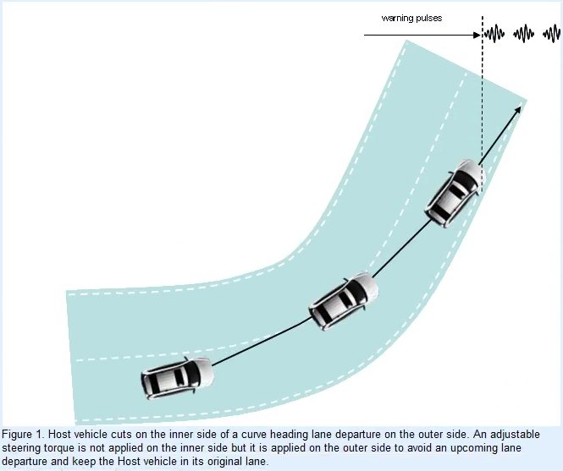

#### 3.3 Emergency LKA

##### 3.3.1 Emergency LKA: One pager

Emergency Lane Keeping Aid(E-LKA)

Customer Function

Function Description

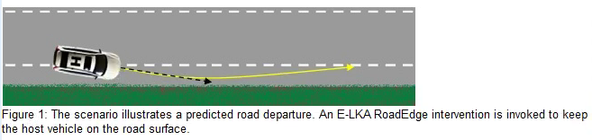

Sensor System

Target Program

Competition

##### 3.3.2 Emergency LKA: Use cases

Risk for road drparture

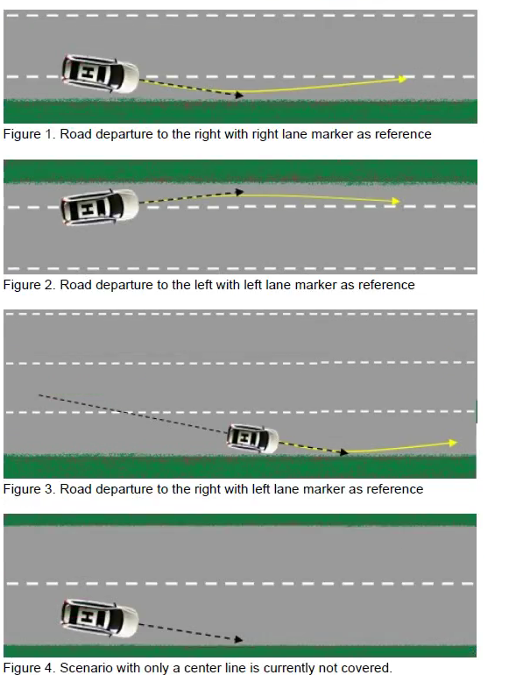

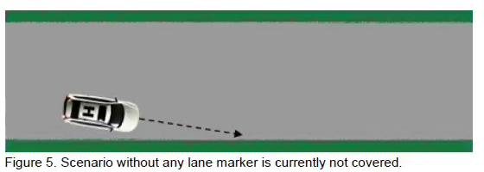

### 4 FUNCTION REALIZATION DESCRIPTIONS

The structure of this documnent is explained below:

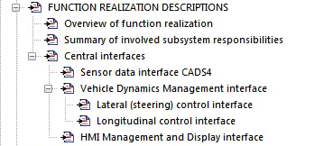

#### 4.1 Overview of function realization

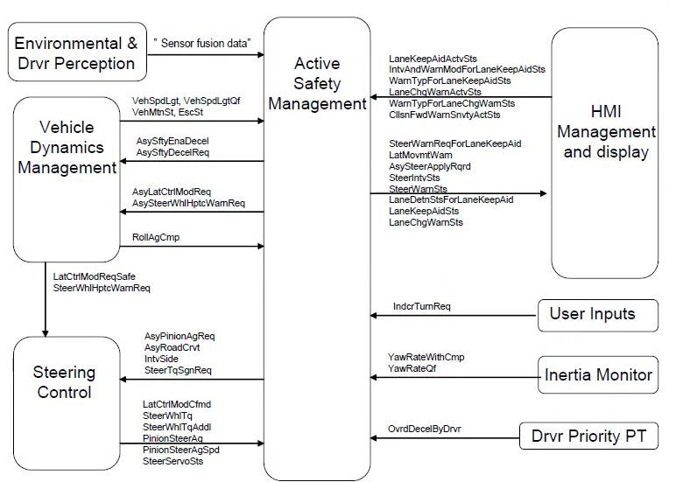

#### 4.2 Summary of involved subsystem responsibility

1) Active Safety Management

2) Environmental and Driver Perception

3) Vehicle Dynamics Management

4) Steering Control

5) Inertia Monitor

6) HMI Management and Display

7) Driver Priority(PT)

8) User Inputs

#### 4.3 Central interfaces

##### 4.3.1 Sensor data interface CADS4

Sensor fusion data:

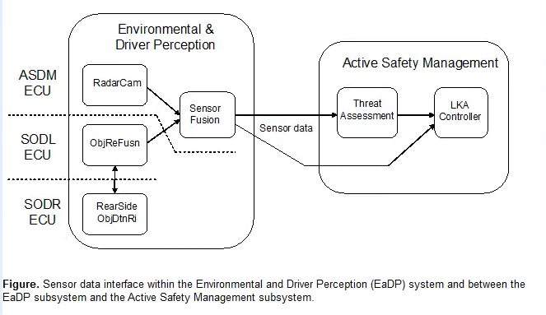

##### 4.3.2 Vehicle Dynamics Management interface

1)Ego vehicle state information

###### 4.3.2.1 Lateral(steering)control interface

1) Steering control during sLKA and eLKA manouvers

2) Haptic warning steering control

3) Hands on functionality

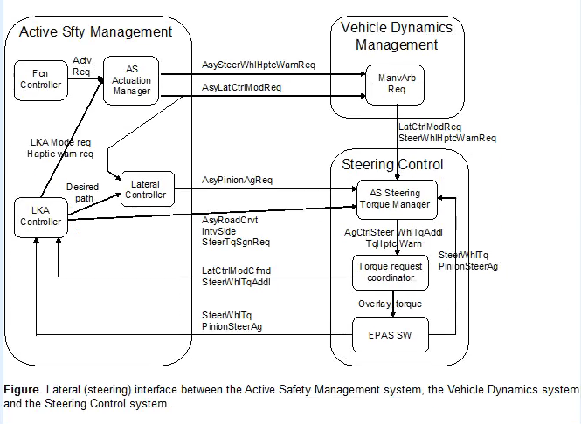

###### 4.3.2.2 Lonitudinal control interface

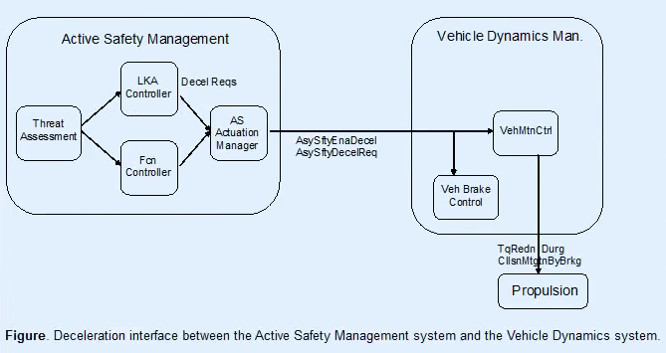

##### 4.3.3 HMI Management and Display interface

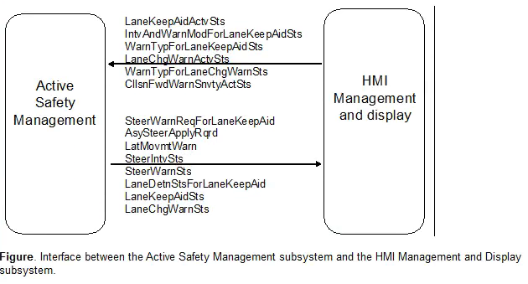

1. HMI warning interfaces

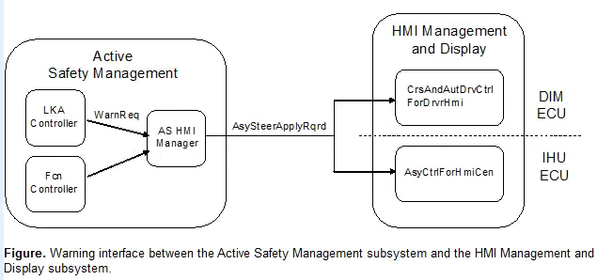

1. Driver settings interface

The HMI Manageent and Display system provides(and stores)the LKA settings sent to the function controller in the ASM system,via the following signals:

LaneKeepAidActvSts(LKA On/Off status setting)

IntvAndWarnModForLaeKeepAidSts(LKA intervention mode setting)

WarnTypForLaneKeepAidSts(LKA warning type setting)

LaneChgWarnActvSts(LDW On/Off status setting)

WarnTypForLaneChgWarnSts(LDW warning type setting)

CllsnAidsnvtySeldSts(collision avoidance sensitivity setting)

1. Interface for presentation of function status

Function status is sent via the signals LaneKeepAidSts and LaneChgWarnSts.

Lane detection status is sent via the signals SteerIntvSts,SteerWarnSts and LaneDetnStsForLaneKeepAid.

### 5 FR REQUIREMETS ON SUBSYSTEMS

This section contains the FR requirements on the subsystems in the logical electrical architecture



#### 5.1 LKA Requirements on Active Safety Management



The following state-chart defines five states according to which the Acitve Safety Management system shall operate for the safety Lane Keeping Aid function

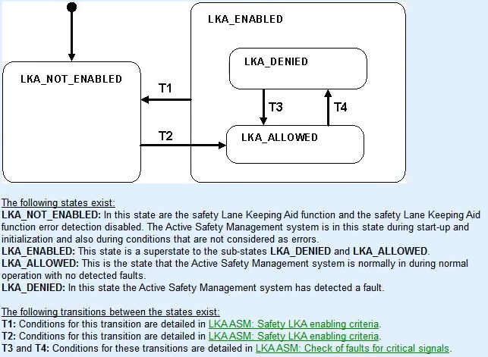

#### 5.2 LKA Requirements on Environment and Driver Perception

This section describes EaDP performance and characteristics,accuracy requiremet. Part of requirements are shown below.

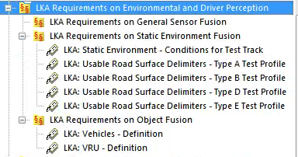

#### 5.3 LKA requirements on Vehicle Dynamics Management

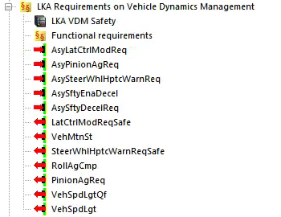

#### 5.4 LKA Requirements on Steering

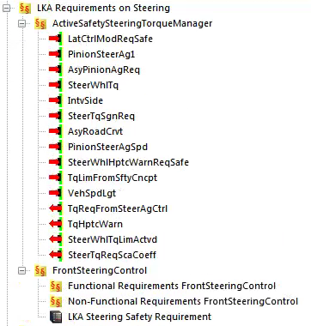

#### 5.5 LKA Requirements on Inertia Monitor



This section describes the performance of inertial sensor

#### 5.6 LKA Requirements on User Inputs

This section describes Direction indication switch



#### 5.7 LKA Requirements on Driver Priority

This section describes Driver Brake information.

